**Quick Overview of Continuous Delivery Pipeline**

* Overview  
  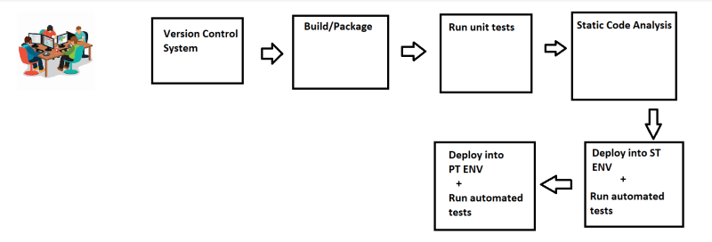
* This pipeline will be triggered by the changes in the Version Control Systems (VCS)

**WOW (Ways of Working)**

* Figure out the manual steps
* Implement manual steps in Pipeline depending on your ci/cd engine
* Steps for gameoflife <https://github.com/wakaleo/game-of-life>
* Softwares requried
  + git
  + jdk 8
  + maven

sudo apt update

sudo apt install openjdk-8-jdk maven -y

Manual steps

git clone https://github.com/wakaleo/game-of-life.git

cd game-of-life

mvn package

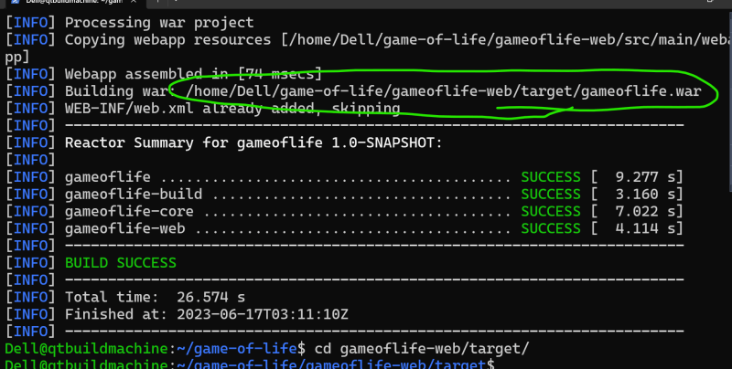

Pipeline in Jenkins

pipeline {

agent any

stages {

stage ('vcs') {

steps {

git 'https://github.com/wakaleo/game-of-life.git'

}

}

stage ('build') {

steps {

sh 'mvn package'

}

}

}

}

Pipeline in Azure DevOps

steps:

- task: Maven@4

inputs:

mavenPomFile: 'pom.xml'

goals: 'package'

**Git**

* Git is a Distributed Version Control System
* Git is Hosted by many providers
  + GitHub
  + Azure Source Repos
  + Code Commit
  + Bit Bucket
  + Git Lab